Design of an Autonomous Avoidance System for Kinect-based Unmanned Vehicle

Min-Joon Kim¹, Jong-Wook Jang²

Department of Computer Enginerring, Dong-Eui University
176, Eomgwang-ro, Busanjin-gu
Busan, Korea
zanenber@naver.com¹, jwjang@deu.ac.kr²

Abstract

The market for unmanned vehicles has been growing rapidly along with technical development and sudden increase in private needs. Some countries currently allow test drives of unmanned vehicles but no country has a administrative system for licensed drives of unmanned vehicles. Even in case of the existing vehicles, negligent accidents often occur under unexpected circumstances due to the frequent malfunction in rear sensors or the blind spots of rear cameras. Only when such minor defects should be complemented, the relevant regulations for commercializing unmanned vehicles may be mitigated. Accordingly, this thesis tries to conduct distance measurement by use of Kinect, a representative depth camera unlike ultrasonic or razor sensors which have been previously used for distance measurement. Kinect calculates distances by measuring the time of flight (TOF) which takes for an infrared ray to return after being shot to an object or target. This camera may be used for collecting depth information in real time because it can receive depth information by an image pixel of the charge-coupled device (CCD). Using such real-time depth information, this thesis proposes to solve the foregoing problems and to design an autonomous avoidance system through distance measurement for unmanned vehicles.

Depth Camera; Unmanned Vehicle; Obstacle Avoidance; Autonomous; Kienct;

I. Introduction

In the past, unmanned vehicles were only recognized as the use for defense industry but in the present, the market for unmanned vehicles has been growing sharply along with technical development and sudden increase in private needs. The Ministry of Science, ICT & Future Planning declared that the market size of unmanned vehicles was USD 25.1 billion in 2015 and expected to be USD 153.7 billion in 2025 with 20% average growth per year. In the private area, completed vehicle companies from Germany, Japan, etc. have also released self-driving cars since Google, a IT company, released a self-driving car. Currently, some countries allow test drives but no country has a administrative system for licensed drives of self-driving cars. In order to commercialize the self-driving cars, the relevant laws, systems and infrastructures should be completely furnished. The Korean industry has failed to expect the potential growth in the unmanned vehicle market. Therefo- re, a plan for developing unmanned vehicles should be prepared and carried forward so as to enter the global market with securing competitiveness in a short term.
This thesis proposes an autonomous avoidance system for unmanned vehicles by way of depth measurement using the depth information received from Kinect to develop technologi- es left behind and solve the issue of commercializing self-driv- ing technologies.

II. How to Format the Page

This thesis proposes that an unmanned vehicle with a self-driving function uses a depth camera as can be seen in the below figure.
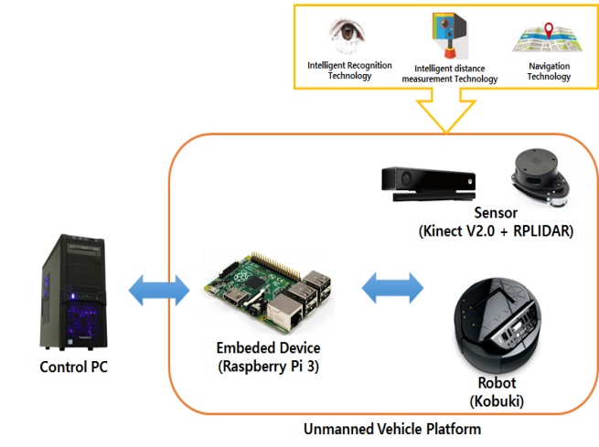
Fig. 1 Model of the Proposed System for Unmanned Vehicles

With the existing commercialized sensors installed on vehicles, the distance from a car ahead and the information thereof can be confirmed by using stereo cameras which perceive a distance from an object based on the difference between both eyes, mono cameras and radars. There is also a method of using razors instead of radars. The respective methods have each strong and weak points in relation to speed, degree of precision, surrounding environment, price, etc. Distance measurement is conducted with Kinect, a representati- ve depth camera unlike the existing ultrasonic or razor sensors used in unmanned vehicles.

III. Hardware Structure

A. Kinect Sensor
It is a representative depth camera and uses the TOF(time of flight) sensor method. It calculates distance information by measuring the time which takes for an infrared ray to return after being shot to an object or target [Figure 2]. The strong point of the TOF camera is to print out depth information in a form of 3D and to make real-time image processing possible.
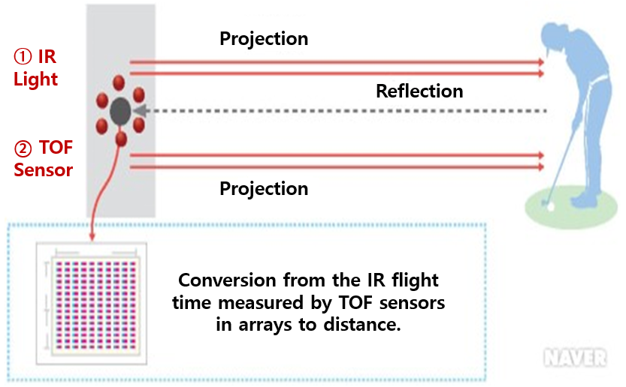
Fig. 2 TOF Principle

B. Kobuiki
Kobuki, TurtleBot by Yujin Robot is proposed as a vehicle. Kobuki is inexpensive and excellent in scalability because numerous sensors, interfaces, and open source software (ROS) are installed thereon.

C. Raspherry Pi 3
Raspherry Pi 3 is chosen as the core embedded module for using Kobuki. Raspherry Pi 3 is appropriate in terms of electricity because it can be used for a long term if using its external battery. Also, it is appropriate in terms of calculation speed because its performance is two times higher than Raspherry Pi 2.

D.Control PC
Kobuki as a vehicle platform and a desktop PC available for communications and controls are used.

E.RPLIDAR
It is a device which measures a distance to an object by use of razors. By spinning, each distance by degree is measured (r, θ) and a surrounding map is made by marking dots on each polar coordinates. It spins 5 times per second and measures a distance for each 1 degree.
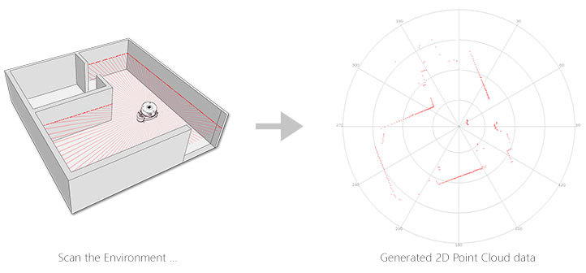
Fig. 3 Map prepared by RPLIDAR (Source:Slamtec)
By connecting it to a computer with a USB cable, a map as in the [Figure 3] can be obtained. It also supports Arduino or ROS.

IV. Software Structure

In order for surrounding circumstances to be perceived, for distances to be measured and for an unmanned vehicle to make self-driving from a point of departure to destination possible by using the depth information obtained from Kinect, the unmanned vehicle provides sensing information so as to prepare a map by itself.
It is SLAM (simultaneous localization and mapping) that has appeared in order for the unmanned vehicle to perceive the present location and prepare a map by sensing surrounding circumstances while driving in unknown places. This SLAM has various algorithms, based on which a map is prepared. Based on the prepared map and the path finding algorithms, a navigation function is vitalized.
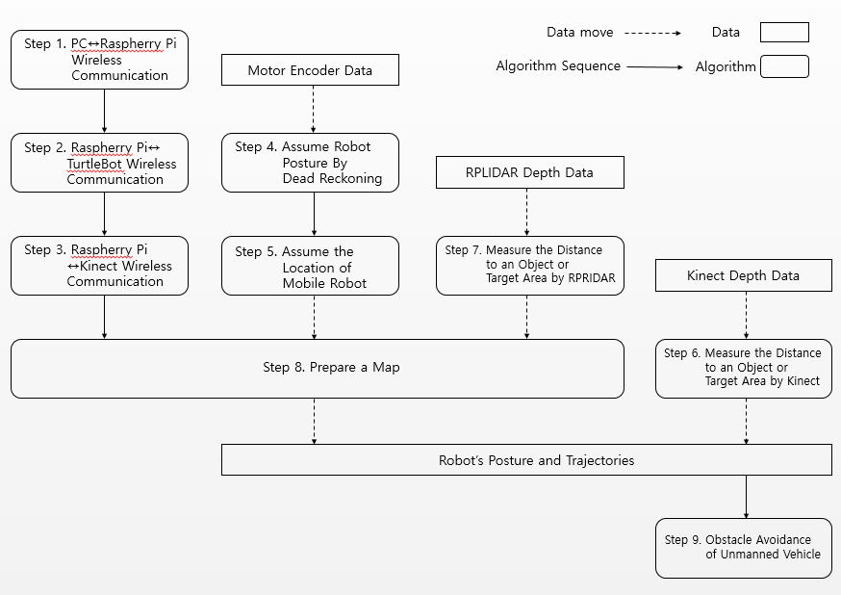
Fig. 4 Sequence Diagram of the Proposed System Model

As described in [Figure 4], a desktop PC makes wireless communications to prepare a map and Raspherry Pi for controlling various sensors and to control Kobuki for emergency. The PC and Raspherry Pi are implemented in Linux. Rasphery Pi is connected with Kobuki so that communications are made between Kobuki and the PC. Sensing information obtained from the connection between Raspherry Pi and RPLIDAR is transmitted to the PC and then, a map for surrounding circumstances is prepared on the PC. Based on the prepared map, Kobuki may avoid obstacles by applying the navigation algorithm. Moreover, the depth information obtained from Kinect connected to Raspherry Pi also may make avoidance possible when a certain object approaches.

V. Conclusion

This thesis proposes to design an autonomous avoidance system for Kinect-based unmanned vehicles. In relation to drones, self-driving cars, recognition technology, Kinect is regarded as a technology bringing high expectations in the future due to its strong points: 3D depth information can be printed out in a form of map, real-time image processing can be conducted and less noises are produced by light changes in comparison with other cameras. This thesis proposes a system to avoid a man or object that may suddenly appear or approach in blind spots or surroundings while driving. By implementing the proposed system in the future, it is aimed to verify whether the system is appropriated for autonomous driving and to secure technical skills by making up for the weakness if any. Also, studies on effective self-driving are to be conducted in the future by screening and selecting improved algorithms among others in terms preparation of a map for self-driving and by applying the optimal algorithm to the Kinect-based unmanned vehicle in the subsequent experiments.

Acknowledgment

This thesis has been supported by the 2016 Human Resource Development Project for Leading New Local Business(20160
1700001) of National Research Foundation of Korea (Busan Techno Park-2015DB0160001)

References

[1] 5-Year Plan for Developing Unmanned Vehicles for Invigorating the Industry thereof and Creating Jobs (Draft), National Science & Technology Council
[2] KB Knowledge Vitamin: Status of Domestic and Foreign Industries for Unmanned Vehicles, Management Institute of KB Financial Group
[3] Let’s Start Robot Programing with ROS, Yoon-Seok Pyo

